**Tugas 12 – W3 Css Animation**

**Code :**

<!DOCTYPE *html*>

<html *lang*="en">

<head>

    <meta *charset*="UTF-8">

    <meta *http-equiv*="X-UA-Compatible" *content*="IE=edge">

    <meta *name*="viewport" *content*="width=device-width, initial-scale=1.0">

    <title>Tugas 12 - W3.CSS Animation</title>

    <link *rel*="stylesheet" *href*="assets/css/w3.css">

    <style>

        img {

           width: 40%;

        }

    </style>

</head>

<body>

    <div *class*="w-container">

        <div *class*="w3-container w3-card w3-red w3-center">

            <h1>W3 Animation Effects</h1>

        </div>

        <div *class*="w3-container w3-card w3-margin w3-center w3-padding-16">

            <img *src*="assets/images/img_snowtops.jpg" *class*="w3-animate-top">

        </div>

        <div *class*="w3-container w3-card w3-margin w3-center w3-padding-16">

            <img *src*="assets/images/suzy.png" *class*="w3-animate-spin">

        </div>

        <div *class*="w3-container w3-card w3-margin w3-center w3-padding-16">

            <img *src*="assets/images/mypic.webp" *class*="w3-animate-fading">

        </div>

        <div *class*="w3-container w3-card w3-margin w3-center w3-padding-16">

            <img *src*="assets/images/img_tree.png" *class*="w3-animate-right">

        </div>

        <div *class*="w3-container w3-card w3-margin w3-center w3-padding-16">

            <img *src*="assets/images/img_car.jpg" *class*="w3-animate-left">

        </div>

        <div *class*="w3-container w3-card w3-margin w3-center w3-padding-16">

            <img *src*="assets/images/paper.gif" *class*="w3-animate-zoom">

        </div>

        <div *class*="w3-container w3-card w3-margin w3-center w3-padding-16">

            <img *src*="assets/images/mobil.jpg" *class*="w3-animate-bottom">

        </div>

    </div>

</body>

</html>

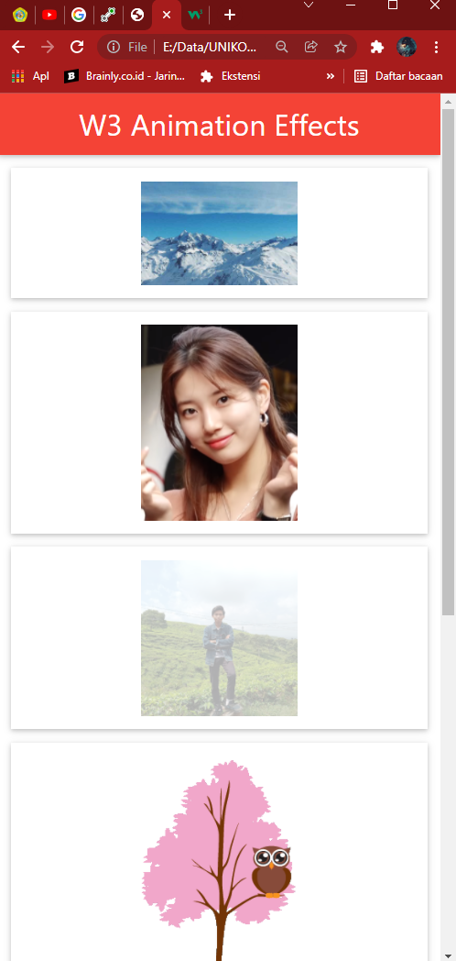**Screenshot:**